Play Wales national conference 2025 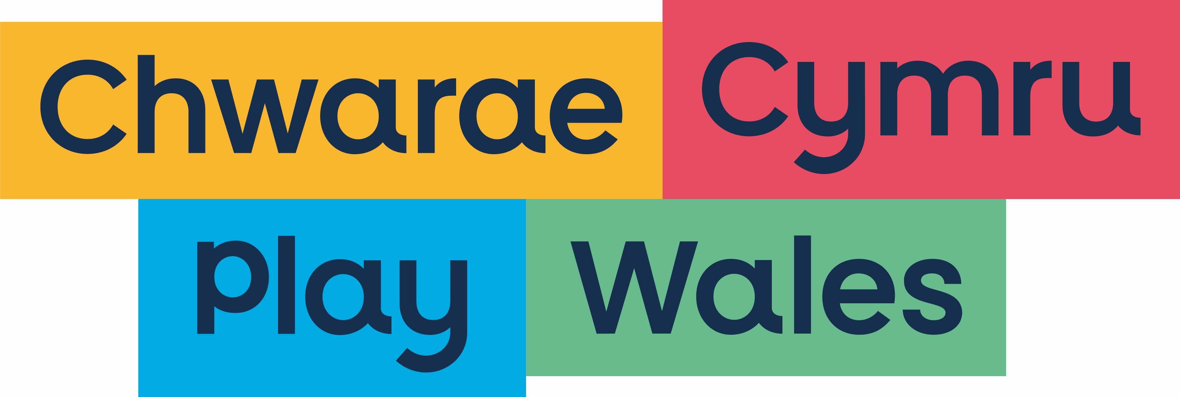
workshop form

Please complete details for the workshop you would like to present at our 2025 national conference by 25 June 2025 and send to events@play.wales

Workshop sessions will last 60 minutes and we may ask you to run your workshop more than once.

1. Facilitator details

Name
Job title
Organisation
Contact phone number
Email

2. Workshop details

Session title |  |  | Level of workshop experience
 |  |  |  | Experienced
 |  |  |  | Some experience
 |  |  |  | Little/no experience
Have you run this workshop before?

 |  | Yes
 |  | No
If yes please give details

Target audience  * Please read note below |  |  | Type of workshop:
 |  |  |  | Theory
 |  |  |  | Practical
 |  |  |  | Research
Topic area

 | Play sufficiency
 | Play and health
 | Workforce development
 | Play in schools
 | Play and planning
 | Play and play areas
 | Playwork
 | Play and early years
 | Play and inclusion
 | Other
If you ticked other, please describe

*This conference is aimed at a broad range of practitioners, and we would prefer all workshops to reflect this. However, if you feel that your workshop would be best suited to a specific audience then please indicate.

3. Equipment required (please tick)

Flip chart
Screen
Speakers

Please note – if you require the use of a laptop please contact us at events@play.wales in advance.

4. Biographical details (no more than 100 words)

5. Synopsis of session (no more than 100 words)

Main aim of your workshop

Points to be covered

