EQUAL OPPORTUNITIES MONITORING FORM | 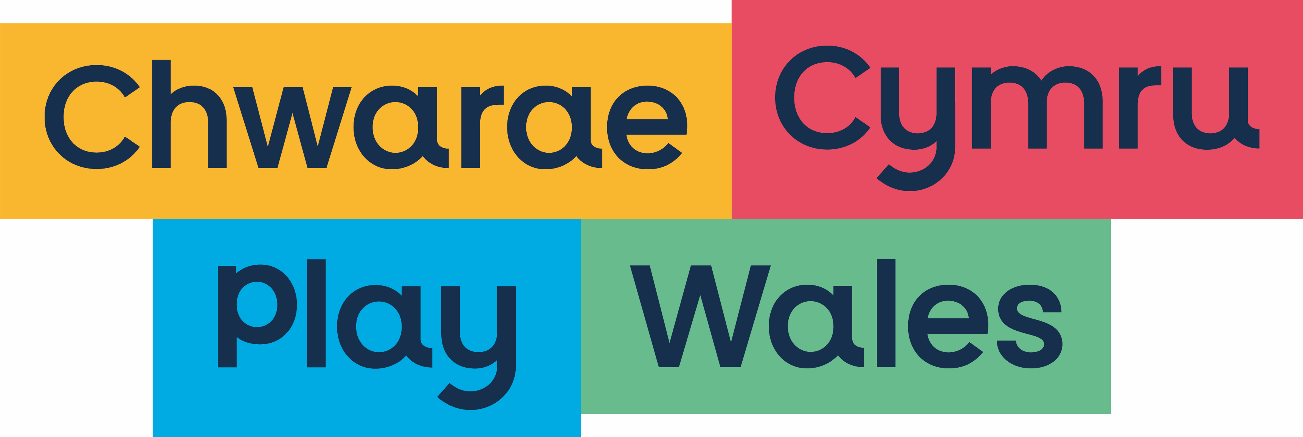

Play Wales aims to be an equal opportunity organisation, and selects candidates solely on merit irrespective of race, age, colour, ethnic or national origins, marital status, gender, gender identity or gender expression, sexual orientation, disability, religion or beliefs. In order to monitor the effectiveness of our equal opportunities policy we ask all applicants to provide the following information:

Please tick one box only in each section
ETHNIC ORIGIN: I would describe my ethnic and cultural origin as:
WHITE |  | MIXED / MUTIPLE ETHNIC GROUPS
English |  | Any other mixed background, please write in
Welsh |  | White and Black Caribbean
Scottish |  | White and Black African
Northern Irish |  | White and Asian
British |  | Prefer not to say
Irish |  | Any other mixed background, please write in
Gypsy or Irish Traveler |  | ASIAN / ASIAN BRITISH
European |  | Indian
Prefer not to say |  | Pakistani
Any other white background, please write in |  | Bangladeshi
 |  | Chinese
 |  | Prefer not to say
 |  | Any other Asian background please write in
BLACK / AFRICAN /CARIBBEAN / BLACK BRITISH |  | ANY OTHER ETHIC GROUP NOT LISTED
African |  | Arab
Caribbean |  | Prefer not to say
Prefer not to say |  | Any other ethnic group please write in
Any other Black / African / Caribbean background please write in

WELSH LANGUAGE:
Fluent in Welsh |  |  | Can write Welsh
Can speak Welsh |  |  | Do not communicate in Welsh
B. GE GGENDER
Male |  |  | Female
I prefer to self-describe
DATE OF BIRTH
DISABILITY
Do you consider yourself to be disabled? |  |  | YES | NO
The Equality Act 2010 defines a disability as a ‘physical or mental impairment that has a substantial and long-term negative effect on your ability to do normal daily activities’.

I hereby give my consent for the information contained in this form to be processed for monitoring purposes

Signed: |  | Date:

