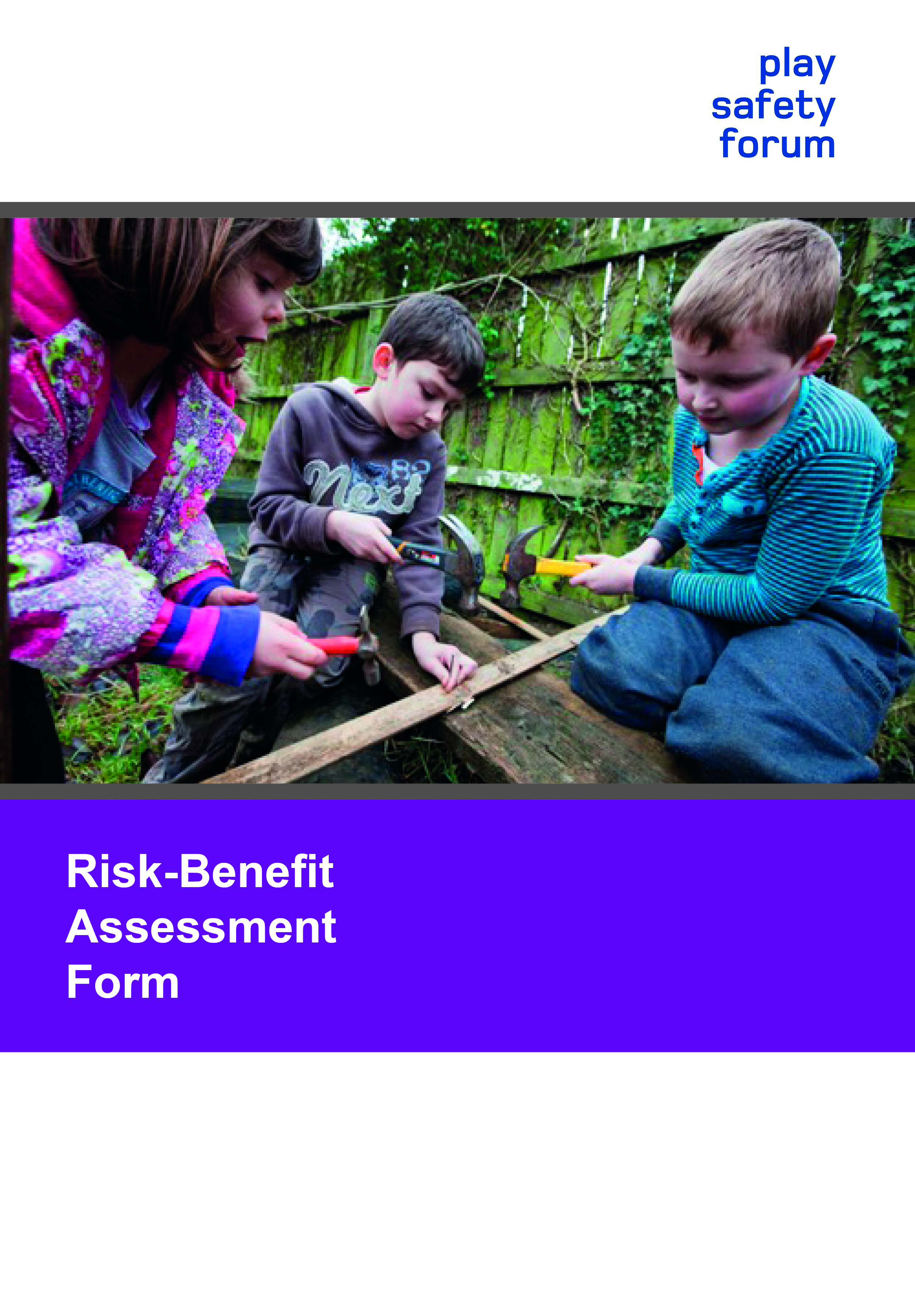
Introduction

The Play Safety Forum, formed in 1993, exists to consider and promote the wellbeing of children and young people through ensuring a balance between safety, risk and challenge in respect of play and leisure provision.

Managing Risk in Play Provision: Implementation Guide shows how play providers can develop an approach to risk management that takes into account the benefits to children and young people of challenging play experiences, as well as the risks. It starts from the position that, while outside expertise and advice are valuable, the ultimate responsibility for making decisions rests with the provider.

This Risk-Benefit Assessment Form was co-authored by David Ball, Tim Gill and Bernard Spiegal on behalf of the Play Safety Forum. Sponsorship was provided by, and the copyright belongs to: Play Scotland, Play England, Play Wales and PlayBoard Northern Ireland.

All rights reserved. The Risk-Benefit Assessment Form can be adapted to suit the provider’s needs, but the Play Safety Forum accepts no liability or
responsibilities for amendments.

Copyright © 2014 by Play England, Play Scotland, Play Wales and PlayBoard Northern Ireland

Printed in Scotland, UK
ISBN 978-0-9556647-8-6

Acknowledgements

We extend our grateful thanks to those who supported the pilots in various settings: Debbie Thelwell, (Little Angels Childcare and Nurseries Ltd); Penny Gosling (Kym Allan Health & Safety Consultants); Mike Garner (Cyngor Sir Ceredigion County Council); and Paul Collings (Timberplay)

Risk-Benefit Assessment Form

Purpose and scope of form

This form is designed to support a balanced approach to risk management using the process of risk-benefit assessment (RBA). It is aimed at those involved in providing play opportunities in a range of contexts, including play areas, public parks, green spaces, out-of-school childcare settings, playwork settings, schools and early years services. It builds on the guidance document Managing Risk in Play Provision: Implementation guide (2nd edition), published in 2013 by the Play Safety Forum with Play England, Play Wales, Play Scotland and PlayBoard Northern Ireland. See this publication for a fuller discussion of the principles and approach set out here.

Those using this form should focus on the significant risks that the play provision gives rise to The Health and Safety Executive (HSE) defines significant risks as those that go beyond everyday life and that “are capable of creating a real risk to health and safety which any reasonable person would appreciate and would take steps to guard against.”

Why risk-benefit assessment?

Risk management in play contexts is different from workplace or factory contexts in one crucial respect. In play provision, a degree of risk is often beneficial, if not essential. Children and young people enjoy challenging, adventurous play opportunities where they can test themselves and extend their abilities. Giving children the chance to encounter hazards and take risks provides other benefits, such as the chance to learn how to assess and manage these and similar risks for themselves. Hence accidents and injuries are not necessarily a sign of problems, because of the value of such experiences in children’s learning. Unlike conventional risk assessment, RBA takes account of benefits by bringing together consideration of risks and benefits when deciding on appropriate responses.

Judgements about the balance between risks and benefits can be complicated. They involve many factors, and are often partly subjective. For example, children may be unpredictable in their play, and have widely varying interests and competences; different providers may have different aims, goals and values, which may be expressed in widely varying approaches; and the context of a site, and the level and style of supervision, are important local factors. Guidance such as play equipment standards help to set reference points, but do not provide an absolute answer, nor do they take into account local circumstances.

Some play environments and structures are complex, and go beyond everyday experience. Judgements about structural stability, water hygiene, head traps or structures built into trees, for instance, may require some technical knowledge and specialist expertise. However, other cases will not involve such expertise: decisions can be based on everyday experience, skills and knowledge. Different situations will require different types and levels of expertise, and this form is designed to reflect this.

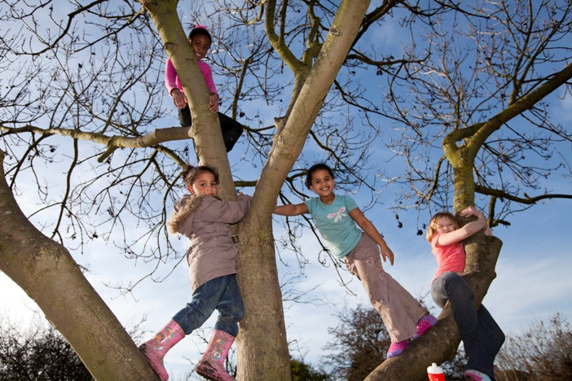

Risk-Benefit Assessment in Practice

Incorporating RBA into your risk management system is a significant step. It may involve changes in principles, procedures and practice at many levels, including thinking and understanding about children and their play and development, overall values and direction, service management, staff and site supervision, and ongoing maintenance and inspection procedures. Some kind of organisational review or training may be helpful in ensuring that considerations of the benefits of risk in children’s play are properly understood and implemented. When first introducing the form, some piloting and group/team discussion is likely to be useful.

Structure of form

Before the form, there is a table for recording the details of the risk-benefit assessment. The form is split into two parts, to reflect the different levels of expertise that may be involved. The main form sets out the factors to be addressed in any overall RBA. The supplementary form asks about the knowledge and/or specialist expertise that may – or may not - be needed when carrying out a particular RBA. A glossary at the end gives brief definitions of some of the key terms. This form is available in two formats: Word 2007 (with a blank form) and pdf (with a worked example) at
www.playengland.org.uk

www.playscotland.org
www.playwales.org.uk
www.playboard.org
This form is not set in stone: users may find it useful to make amendments or adaptations.

Overview of Risk-Benefit Assessment

Project/ proposal name:
Type of assessment (tick one box): | Designer
 | Provider/manager
 | Post-installation
 | Monitoring
Assessor: | Name
 | Position
 | Date
Description and location of facility, feature, activity or equipment:
Date to review risk-benefit assessment:
Signature of senior worker/manager:

Main Form: Risk-benefit assessment
Benefits:
Risks (taking into account any technical information identified in the supplementary form below):
Local factors:
Precedents &/or comparisons:
Decision:
Actions taken:
Ongoing management and monitoring:

Refer to the Glossary at the end of the document for an explanation of terms
Supplementary Form: Knowledge and/or specialist expertise needed (if any) for this risk-benefit assessment

Use this table to give information about any additional specialist or technical expertise that is felt to be necessary. In some circumstances, no such input will be needed. If this is the case, a suitable note such as ‘none applicable’ or ‘N/A’ should be made in the table (which should otherwise be left blank). In other circumstances, such as those involving bespoke structures or unusual sites, specialist input may be appropriate. Such expertise might, for example, cover the following topics: trees, structural engineering, rope specialisms, water, soil, EN standards and maintenance. In rare cases, other areas of expertise may also be needed. Ensure that relevant information is noted above in the main form.
Knowledge or specialism | Person providing the knowledge/ carrying out the assessment | Any checks carried out and actions proposed

Glossary

Actions taken: This should state the actions taken as a result of the decision reached. The choices could include:
- None
- Introduce or increase monitoring of benefits and/or risks
- Introduce or increase supervision
- Book technical inspection
- Contact manufacturer to make modifications
- Introduce other measures to reduce risks
- Introduce additional features or activities that increase the level of risk and challenge or other benefits
- Meet with parents/users to raise awareness of approach to risk and benefit
- Remove facility/structure, or suspend activity

Benefits: the specific, positive things that children and young people gain through the play opportunities that are under assessment (social, physical, emotional, educational, psychological, etc.).

Decision: this is the assessor’s conclusion following a risk-benefit assessment. The choices could include:
- Proceed/continue with no adjustments to the play environment or working practices and continue to monitor
- Proceed/continue with some specific adjustments to the play environment or working practices while continuing to monitor
- Cease use of the play environment until work can be carried out/further assessments can be made

Local factors: any relevant issues that are specific to the setting being assessed (for example, proximity to housing, characteristics of local residents and typical users, nature of supervision, access to the site, size of the site, proximity to busy roads or other hazards, etc.). Any relevant supporting policies and strategies should also be mentioned here.

Ongoing monitoring and management: State here any future actions that may need to be taken. These could include:
- Maintenance schedules
- Inspection regimes
- Reviews of accident records, injuries or other outcomes
- User feedback exercises

Precedents and/or comparisons: similar equipment, environments, loose parts or potential situations where play is taking place either locally or elsewhere. This section is particularly helpful in relation to unusual, innovative, unconventional or novel initiatives, to help to justify departures from standard approaches. It may be left blank in the case of straightforward projects.

Risk-benefit assessment (RBA): a tool to aid risk management that explicitly brings together considerations of risks and benefits in a single judgement.

Risks: in general use, the word ‘risk’ refers to the probability, likelihood or chance of an adverse outcome. In risk management contexts, the word tends to include a measure of the seriousness of the outcome, as well as its probability. HSE defines risk as the chance that “somebody could be harmed by [a hazard] together with an indication of how serious the harm could be.”

Other language used when assessing risks and benefits for play

Hazards: hazards are potential sources of harm. The HSE defines a hazard as "anything that may cause harm, such as chemicals, electricity, working from ladders, an open drawer, etc." There is no action and no object that may not be hazardous in certain circumstances. It is impractical to treat all potential hazards with the same degree of seriousness. In managing risk, judgements need to be made about:
- Which risks and hazards need to be modified or removed
- Which risks and hazards might be acceptable or desirable, because of their benefits to children and young people
- What, if anything, is to be done about risks and hazards that have been identified.

Safe: ‘safe’ or ‘safety’ is perhaps the most commonly encountered term in debates about children and risk, such as: "Is this playground/park/tree/public square safe?" There is no simple answer to questions like this, because the word ‘safe’ means different things to different people (see Managing Risk in Play Provision: Implementation guide, p. 31).

